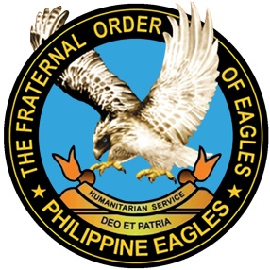
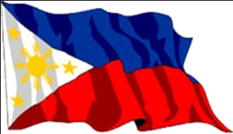
THE FRATERNAL ORDER OF Eagles
(Philippine Eagles)

First Philippine Born Fraternal Socio-Civic Organization
“Service Through Strong Brotherhood”

NATIONAL I.D. APPLICATION FORM
NAME: ( LAST NAME, FIRST NAME, MIDDLE NAME ) |  |  |  |  |  |  |  | CLUB POSITION:
HOME ADDRESS:

PERSONAL CONTACT NUMBER: |  | HEIGHT: ( FEET ) |  |  | WEIGHT ( KGS ) | BLOOD TYPE: |  | RELIGION:
CONTACT PERSON IN CASE OF EMERGENCY: |  |  |  |  | CONTACT NO.:
BIRTH DATE: | BIRTH PLACE:
GSIS/SSS: | PHILHEATH: |  |  | PAG-IBIG: |  |  | TIN NO.
CLUB AFFILIATION: |  |  |  | REGION:
CLUB PRESIDENT: |  |  |  |  |  | MEMBER CONTROL NO.
Eagle
2X2 PICTURE

WHITE BACKGROUND
PRESIDENT SIGNATURE |  |  |  |  |  | MEMBER SIGNATURE
Indorsed by:  Eagle ROBERT W. CORCINO JR. |  |  |  |  | Approved by:  Eagle NELSON ALONTO SARAPUDDIN
REGIONAL GOVERNOR, NORTHERN MINDANAO REGION I EY 2022 |  |  |  |  | NATIONAL PRESIDENT EY 2021 - 2022

